**LEBANESE AMERICAN UNIVERSITY**

**USAID – HIGHER EDUCATION SCHOLARSHIP PROGRAM**

**HES - Volunteering Program Verification Form**

This form is to be used to document volunteering hours. If a student volunteers for multiple organizations, a separate form must be used for each organization. **This form must be turned in by the 28th of each month, the latest.**

I certify that the scholar Karim mayasi completed a total of 5 hours of service at InnovaThrive.

The hours were completed hours as per the below:

Hours # 0 (date) _2/12 – 6/12_ (initials of supervisor) __A.K.___

Hours # 0 (date) _9/12 – 13/12_ (initials of supervisor) __A.K.___

Hours # 0 date) _16/12 – 20/12 (initials of supervisor) __A.K.___

Hours # 5 date) _23/12 - 27/12 (initials of supervisor) __A.K.___

Brief description of the activities the scholar performed or participated in:

I have conducted research on blockchain technology and its impact on various factors in the present day. The research included a definition of blockchain and an exploration of its key components, such as decentralization, immutability, and security. I examined how blockchain is being applied across different industries, including finance, supply chains, and healthcare. Additionally, I discussed the advantages of blockchain, such as enhanced transparency, reduced fraud, and cost efficiency. The research also covered its challenges, including scalability issues, regulatory concerns, and integration with existing systems. Lastly, I explored future directions for blockchain technology and its potential to transform industries in the coming years.

Written feedback about the scholar’s performance:

Karim Mayasi’s research into blockchain technology and its impact across industries was detailed and well-rounded. His exploration of key blockchain components, applications, and industry use cases showcased a solid grasp of the technology. Karim effectively addressed the advantages and challenges, such as transparency and scalability, demonstrating a forward-looking perspective by considering future directions for blockchain development.

Please rate the overall performance of the scholar at your organization:

|  |  |  |  |
| --- | --- | --- | --- |
|  | Mastery (5) | Proficient (3) | Emerging (1) |
| **Problem solver** | X |  |  |
| **Engaged & Committed** | X |  |  |
| **Open-minded & multicultural** | X |  |  |

Signature

& stamp

__________________________

_

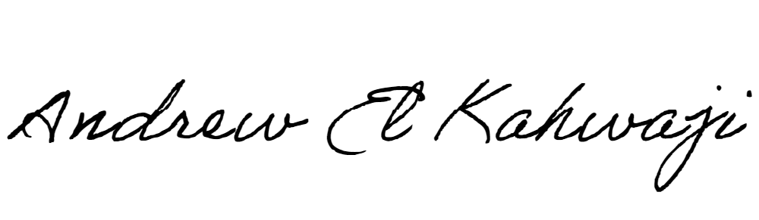

Printed Name _Andrew El Kahwaji_

Date __26/12/2024___

Email __andrew.lifesculptor.coo@gmail.com __

Phone __+961 71 914 378__